1.

(3.7\*4 + 3.0\*5 + 2.3\*3) / 12

ans =

3.0583

2.

a = pi \* (1/20) \* [0:19]

a =

Columns 1 through 18

0 0.1571 0.3142 0.4712 0.6283 0.7854 0.9425 1.0996 1.2566 1.4137 1.5708 1.7279 1.8850 2.0420 2.1991 2.3562 2.5133 2.6704

Columns 19 through 20

2.8274 2.9845

cos(a)

ans =

Columns 1 through 18

1.0000 0.9877 0.9511 0.8910 0.8090 0.7071 0.5878 0.4540 0.3090 0.1564 0.0000 -0.1564 -0.3090 -0.4540 -0.5878 -0.7071 -0.8090 -0.8910

Columns 19 through 20

-0.9511 -0.9877

3.

t = [0:0.1:5]

plot(t, exp(-t)

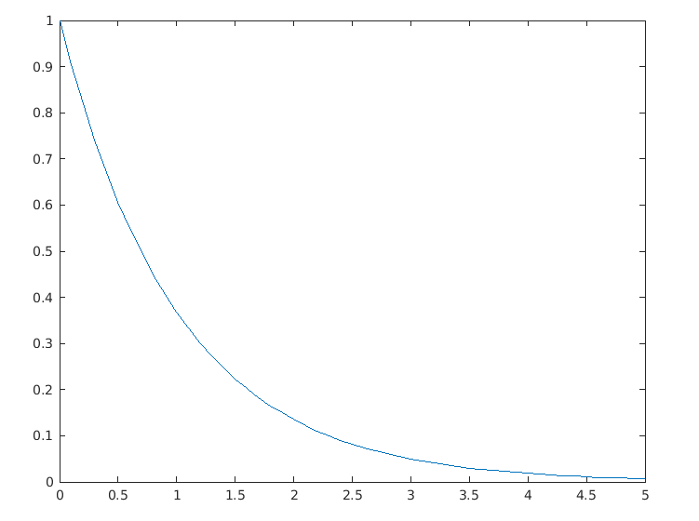

a = pi \* 0.05\*[0:120];

plot(a, cos(a))

